Description:

Stock Chart is used to display the stock prices for the given period. We can also display trends by using the trend line option available. Stock prices are listed on the vertical axis and time increments are listed on the horizontal axis. The ranges for prices and time periods are auto-adjusted based on the range of values provided. Each bar on the stock represents 4 values. Open and Close will be stock open and close prices for given day, and Low, High values will be the min, max values of that stock for the day. For example, On March 1, let the stock price of company A opens at 30$ and at the end of the day closed at 50$. But during the day it go down to 10$ and went up to 199$. So, these will be plotted in Low and High fields.

How to use visual:

1. Prepare data for your company stock prices over month, quarter, or year. It should have following fields:
   1. Date: Dates that you are interested in
   2. Open: Opening price of the stock for the day
   3. Close: Closing price of the stock for the day
   4. Low: It is the minimum price of the stock for the day
   5. High: It is the maximum price of the stock for the day

For example, on 01 March 2016, let the stock price of company A opens at 30$ and at the end of the day closed at 50$. But during the day, it went down to 10$ and went up to 100$. Then the field values will be like this

1. Date: March 1, 2016
2. Open: 30$
3. Close: 50$
4. Low: 10$
5. High: 100$
6. Load data and load stock chart visual.
7. Chart will load using the default settings and colors

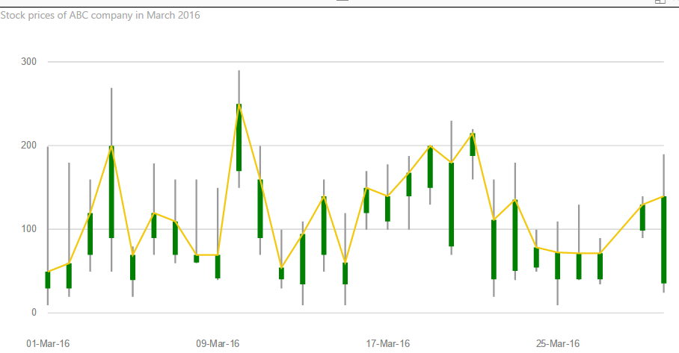

1. If there are multiple entries for any day, then chart will aggregate those values into one using “SUM”. If we want to change the default aggregation, we can do that using the Fields pane

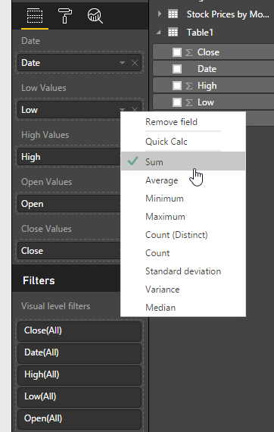

1. We can change the colors of all bars using the “format” pane “Data colors” option.

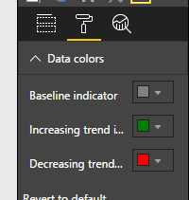

* 1. Baseline indicator: This option will change the vertical bar color

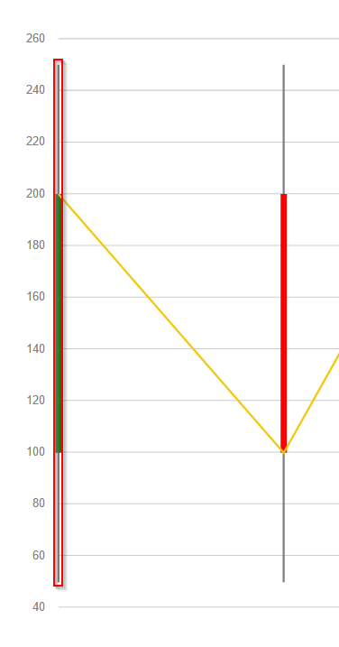

* 1. Increasing trend indicator: If the stock price increased for the day (open < close), then this color will be used
  2. Decreasing trend indicator: If the stock price decreased for the day (open > close), then this color will be used

In the example below, on Jan 01, 2016 price is increased from 100$ to 200$ which is shown in green

On March 01, 2016 price is decreased from 200$ to 100$ which is shown in red

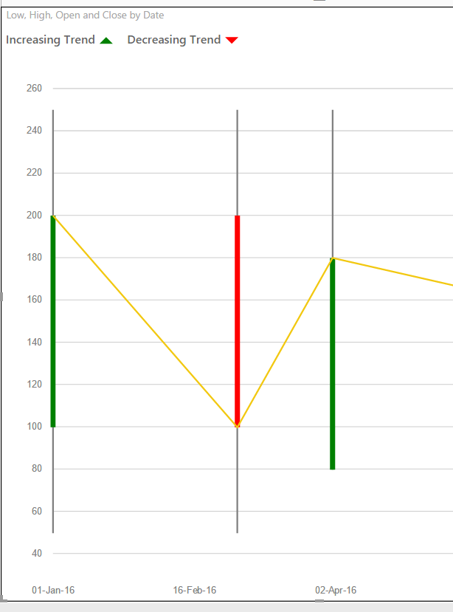

1. We can enable legends that shows the color coding for the chart

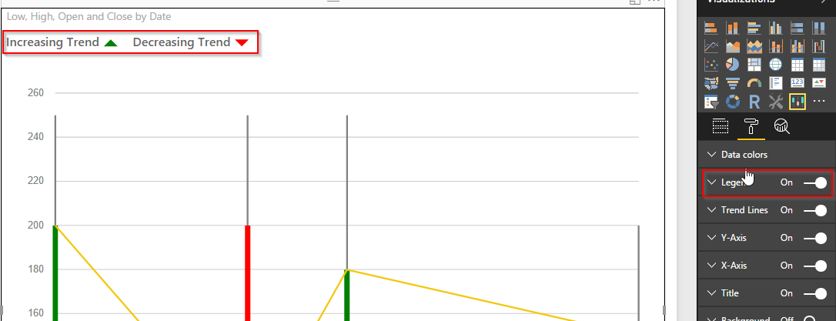

1. We can also enable trend line, which will connect all end of the day stock prices during that period. Options available are:
   1. We can turn it on/off
   2. We can change trend line color
   3. We can set line width

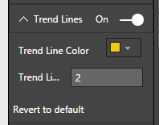

1. We can also turn X and Y axis on/off based on the requirements. Chart will adjust by itself with the extra/less space available

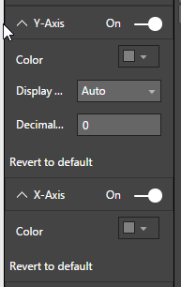

Blog:

Sharing a stock’s historical and recent price movement is easy with Stock Chart. Use this visual to analyze a stock’s performance or investigate potential short- and long-term trends.

The component uses colored vertical bars to illustrate a stock’s significant price points over whatever period you specify. The customizable time ranges allow you to conduct your analyses at whatever level you want. Whether you want to track a stock’s performance over a year, a week, or even over a few hours, this component will help you visualize the relevant price data. By allowing you to control the scope of your data, Stock Chart provides you with the tools you need to shape in specific aspects of a stock’s behavior.

Set up your Stock Chart by choosing your price and time ranges. Stock Chart’s color scheme is intuitive, which makes it easy to present your findings to any type of audience. Red bars indicate a stock’s value has dropped, and green indicates the value has gone up. The stock’s low and high prices over the span of time you’ve selected will be represented by a vertical grey bar.

Do you have any thoughts or feedback on Stock Chart? Please comment below!